**Selected sas code and output for chapter 1**

**Descriptive Statistics in SAS code**

Suppose we want to describe a dataset statistically, the first 10 observations for that data look like the following way:

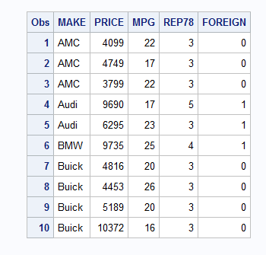

**DATA** auto ; /*creat a data file called "auto" */

input MAKE $ PRICE MPG REP78 FOREIGN ; /* varables.*/

DATALINES; /* input data */

AMC 4099 22 3 0

AMC 4749 17 3 0

AMC 3799 22 3 0

Audi 9690 17 5 1

Audi 6295 23 3 1

BMW 9735 25 4 1

Buick 4816 20 3 0

Buick 4453 26 3 0

Buick 5189 20 3 0

Buick 10372 16 3 0

Buick 4082 19 3 0

Cad. 11385 14 3 0

Cad. 14500 14 2 0

Cad. 15906 21 3 0

Chev. 3299 29 3 0

Chev. 5705 16 4 0

Chev. 4504 22 3 0

Chev. 5104 22 2 0

Chev. 3667 24 2 0

Chev. 3955 19 3 0

Datsun 6229 23 4 1

Datsun 4589 35 5 1

Datsun 5079 24 4 1

Datsun 8129 21 4 1

;

RUN;

PROC PRINT DATA=auto(obs=10); /* to show the first 10 obervations in the data set */

RUN;

PROC FREQ DATA=auto; /* Frequency table */

TABLES make;

RUN;

PROC FREQ DATA=auto; /* cross frequency table */

TABLES make*foreign ;

RUN;

PROC FREQ DATA=auto;

TABLES make*foreign / NOROW NOCOL NOPERCENT ;

RUN;

proc gchart data=AUTO; /* pie chart 8*/

pie MAKE / midpoints="AMC" "Audi" "BMW" "Buick" "Cad." "Chev." "Datsun"

value=none

percent=arrow

slice=arrow

noheading

plabel=(font='Albany AMT/bold' h=1.5 color=depk);

run;

proc gchart data=auto; /* bar graph showing frequency*/

vbar make;

run;

proc gchart data=auto; /* bar graph showing relative frequency */

vbar make /type=percent;

run;

proc gchart data=auto ; /* horizontal bar graph */

hbar make /type=percent;

run;

proc univariate data=auto noprint; /* histogram for all the numerical variables*/

histogram;

run;

proc univariate data=auto noprint; /* histogram for mpg*/

histogram mpg;

run;

proc univariate data=auto plot; /* stem-and-leaf display, and box-plot */

var price;

run;

PROC MEANS DATA=auto; /* summary of selected variables */

VAR mpg PRICE REP78;

RUN;

PROC MEANS DATA=auto; /* summary of selected variables under different categories: Foreign or no*/

CLASS foreign ;

VAR mpg PRICE;

RUN;

PROC UNIVARIATE DATA=auto; /* contains many useful information about the selected variable.*/

VAR mpg;

RUN;

**Example 1.12**

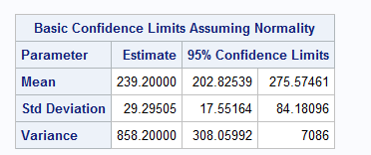

**DATA** silica;

set 'C:\Users\yusha\Desktop\fall 2017\Data sets\SAS\SAS\Exercises&Examples\silica.sas7bdat';/* set statement is to read data in sas. Tell sas where to find the sas data in my computer. You may have to change the address.*/

**run**;

**proc** **univariate** data=silica cibasic; /* Request confidence limits for the mean, standard deviation, and variance based on normally distributed data.*/

**run**;

**Example 1.14**

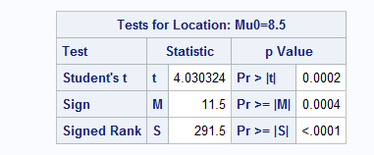

data bones;

input LWRATIO;

datalines;

10.73

8.48

8.52

8.91

8.93

9.38

8.89

8.71

8.87

11.77

8.80

9.07

9.57

6.23

10.48

10.02

9.20

9.29

9.41

10.39

8.38

10.33

9.94

6.66

9.39

11.67

9.98

8.07

9.35

9.17

8.30

9.84

8.37

8.86

9.89

9.17

9.59

6.85

9.93

8.17

12.00

;

run;

proc print data=bones (obs=3);

run;

proc univariate data=bones mu0=8.5 cibasic alpha=0.05; /* Request confidence limits for the mean, standard deviation, and variance based on normally distributed data*/

var LWRATIO;

run;

**data** test;/* Calculate a z value, and associated probability values */

zval=**4.030324**;/*input test statistic you just got*/

z_p_value_onetail=**1**-cdf('NORMAL', abs(zval));/*p-value for one tailed test*/

z_p_value_twotail=**2**\*(**1**-cdf('NORMAL',abs(zval)));/*p-value for two tailed test*/

**run**;

**proc** **print**;

**run**;

**Example 1.15**

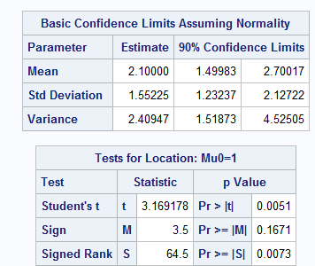

data benzene;

input benzene;

datalines;

0.5

0.9

4.5

3.4

1.0

2.7

1.1

1.9

0.0

0.0

4.2

2.1

0.0

2.0

3.4

3.4

2.5

0.9

5.1

2.4

;

run;

proc print data=benzene;

run;

proc univariate data=benzene mu0=1 cibasic alpha=0.1;

var benzene;

run;

**Example 1.16**

**data** diet;

infile 'C:\Users\yusha\Desktop\fall 2017\Data sets\Exercises&Examples\DIETSTUDY.txt' dlm='09'x FIRSTOBS=**2**;

/* "infile" can read data from external data file such as excel, txt, etc. into sas. 'H:\For Teaching\Stat 2223-001 Elements of Statistics II\Text\Exercises&Examples\DIETSTUDY.txt' tell sas where to find the data in my computer. You may have to change the address. For dlm='09'x for the delimiter is to read the character variables as for ASCII systems (UNIX, Windows, and Linux);

FIRSTOBS=2" tell sas to read data starting from the second row. */

input DIET $ WTLOSS; /* to select the variables */ /* if your variable is qualitative, then follow it with dollar sign */

run;

proc print data=diet (obs=3);

run;

ods graphics on;/*The ODS GRAPHICS statement requests graphical output. */

proc ttest data=diet ci=equal umpu; /*The [CI=](https://support.sas.com/documentation/cdl/en/statug/63033/HTML/default/statug_ttest_sect002.htm#statug.ttest.tteprocci)EQUAL option specifies an equal-tailed confidence interval, and it is the default. The [CI=](https://support.sas.com/documentation/cdl/en/statug/63033/HTML/default/statug_ttest_sect002.htm#statug.ttest.tteprocci)UMPU option specifies an interval based on the uniformly most powerful unbiased test of https://support.sas.com/documentation/cdl/en/statug/63033/HTML/default/images/statug_ttest0016.png.*/

class DIET;/*The CLASS statement is giving the variable that distinguishes the groups being compared*/

var WTLOSS;

run;

ods graphics off;

**OR YOU CAN USE**

**data** diet;

SET C:\Users\yusha\Desktop\fall 2017\Data sets\SAS\SAS\Exercises&Examples\dietstudy.sas7bdat';

**run**;

/*TO READ DATA FROM SAS DATA FILR DIRECTLY*/

**Example 1.17.**

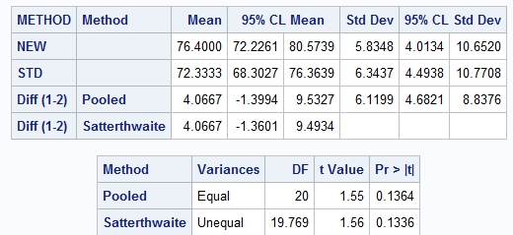

data reading;

infile 'C:\Users\yusha\Desktop\fall 2017\Data sets\Exercises&Examples\READING.txt' dlm='09'x FIRSTOBS=2;

input METHOD $ SCORE;

run;

proc print data=reading (obs=3);

run;

ods graphics on;/*The ODS GRAPHICS statement requests graphical output. */

proc ttest data=reading ci=equal umpu;

class METHOD;/*The CLASS statement contains the variable that distinguishes the groups being compared*/

var SCORE;

run;

ods graphics off;

**Section 11/exercise 1 (a)**

To calculate critical value of F

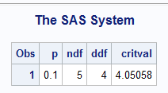

/*F-critical value with upper tail p*/

**data** one;

input p ndf ddf;

critical = finv(**1**-p,ndf,ddf);/*input inverse F function */

cards;

0.1 5 4

;

**proc** **print**;/*print out critical value of F with upper tail=0.1,df of numerator=5, df of denominator=4*/

**run**;